
PACHHUNGA UNIVERSITY COLLEGE
(A Constituent College Of Mizoram University)
Re-dvv
Criterion 7.1.4
water conservation facilities

PICTURES OF RAINWATER HARVESTING/WATER TANKS/BOREWELL
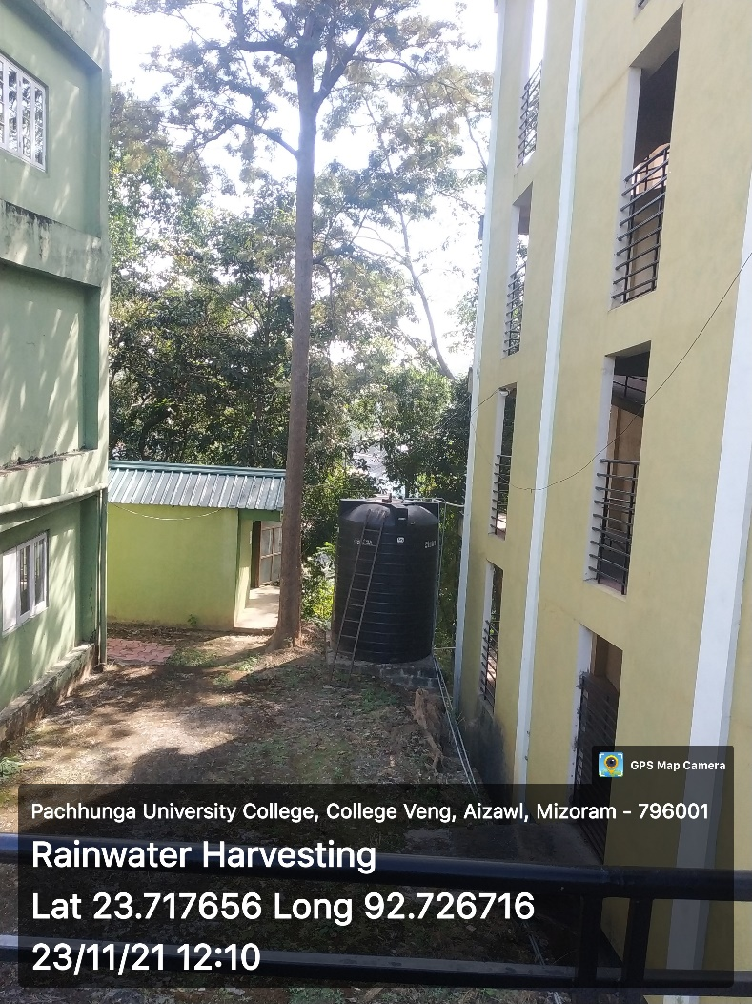

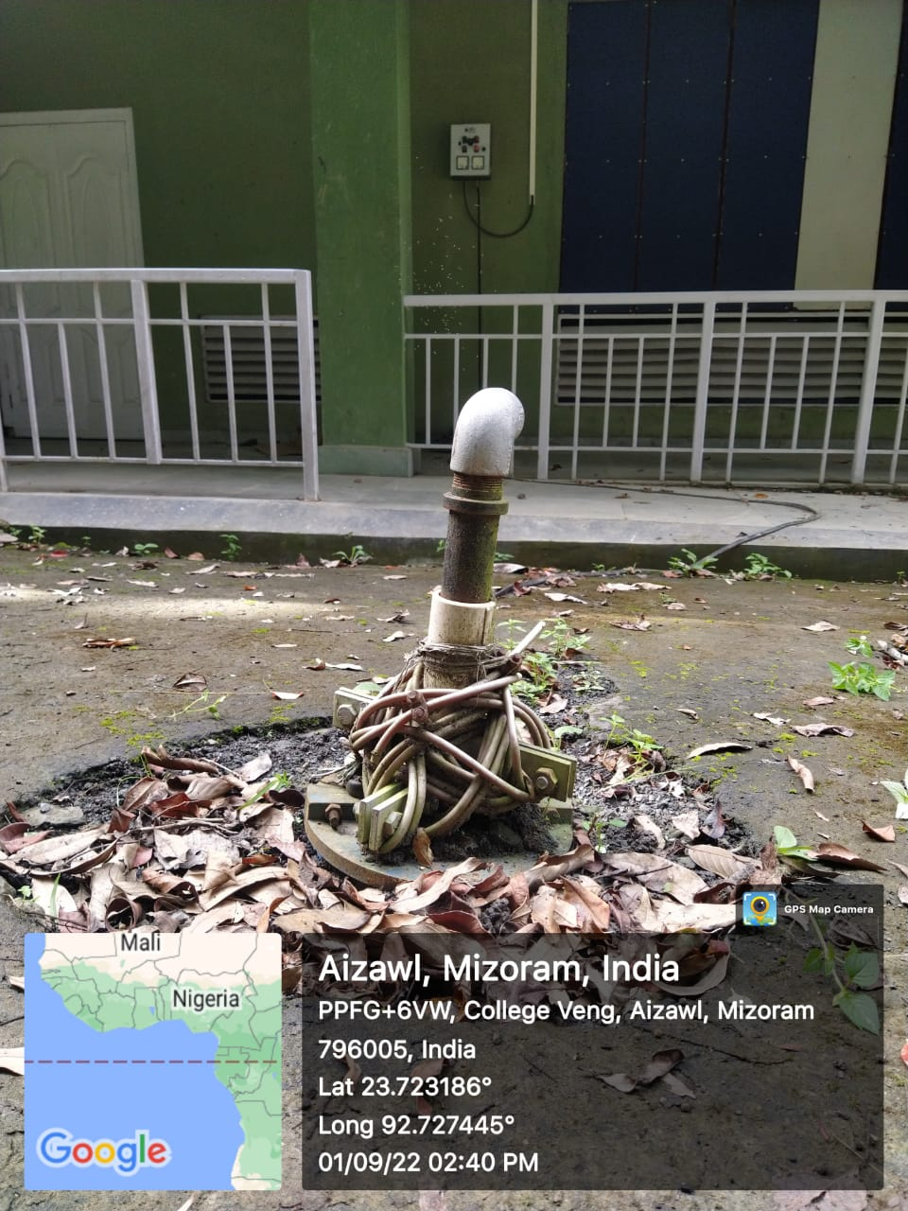
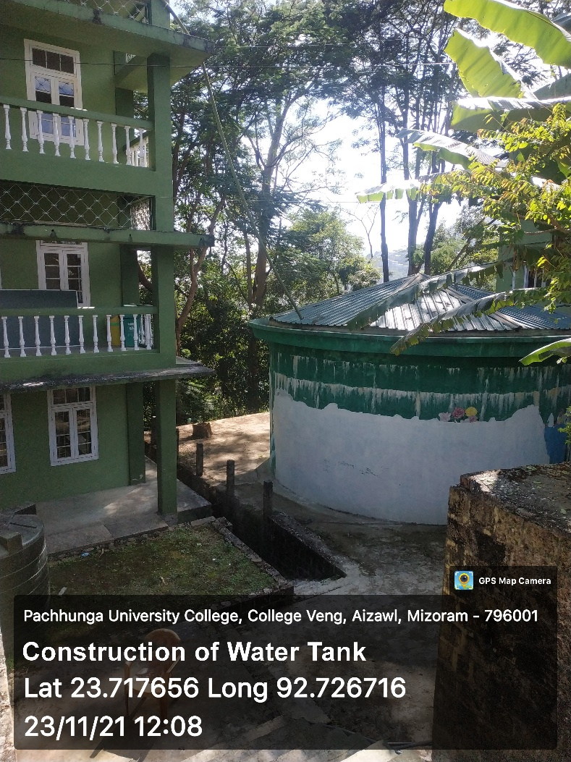
NOTE: PUC Borewell installation was done by the Mizoram State Government under PHE Dept during the year 2019-2020. The college has not been provided with any financial statement or receipts; hence, the college does not have any evidence for financial proof or any other supporting document to avail the claim apart from the picture evidence provided here.

